**To Understand- Co2 Contribution By Different Fossil Fuels, Co2 Emission Over Past 10 Years, Change In Co2 Emission And Co2 Emission In 2020**

**Co2 Contribution By Different Fossil Fuels:**

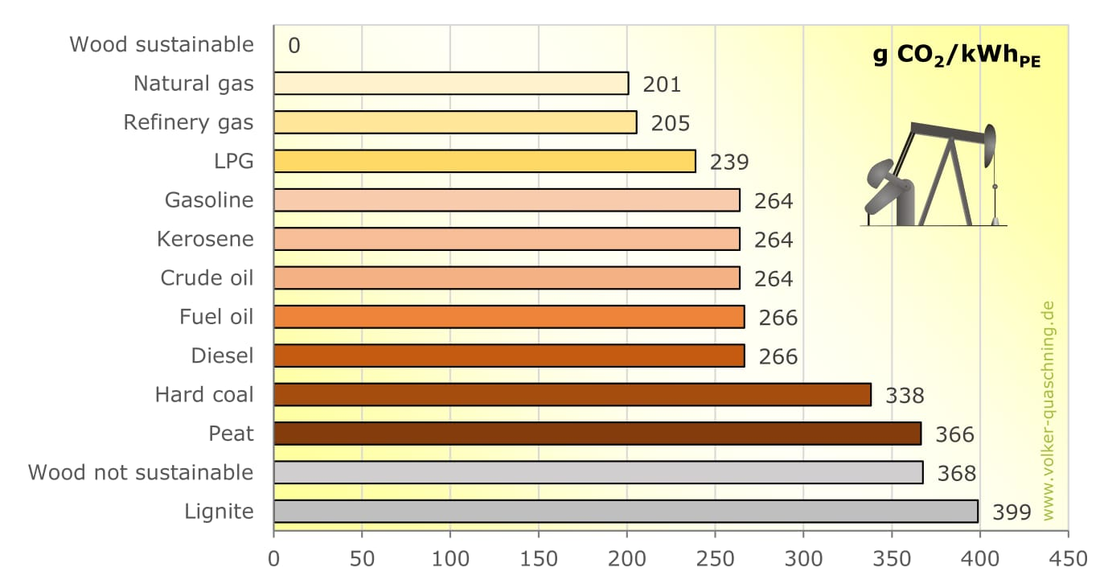**Co2 Emission Over Past 10 Years:**

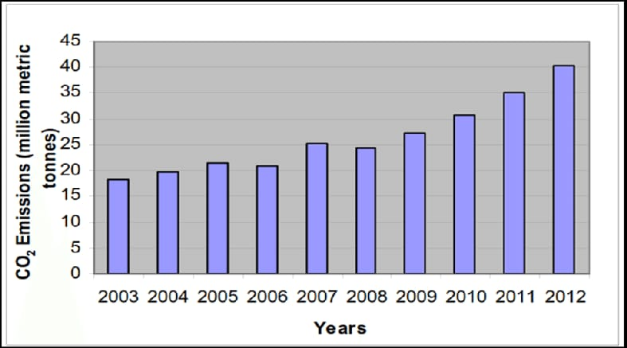

**Change In Co2 Emission And Co2 Emission In 2020:**

